

**Purdue University IEEE ROV Team**

West Lafayette, Indiana, USA

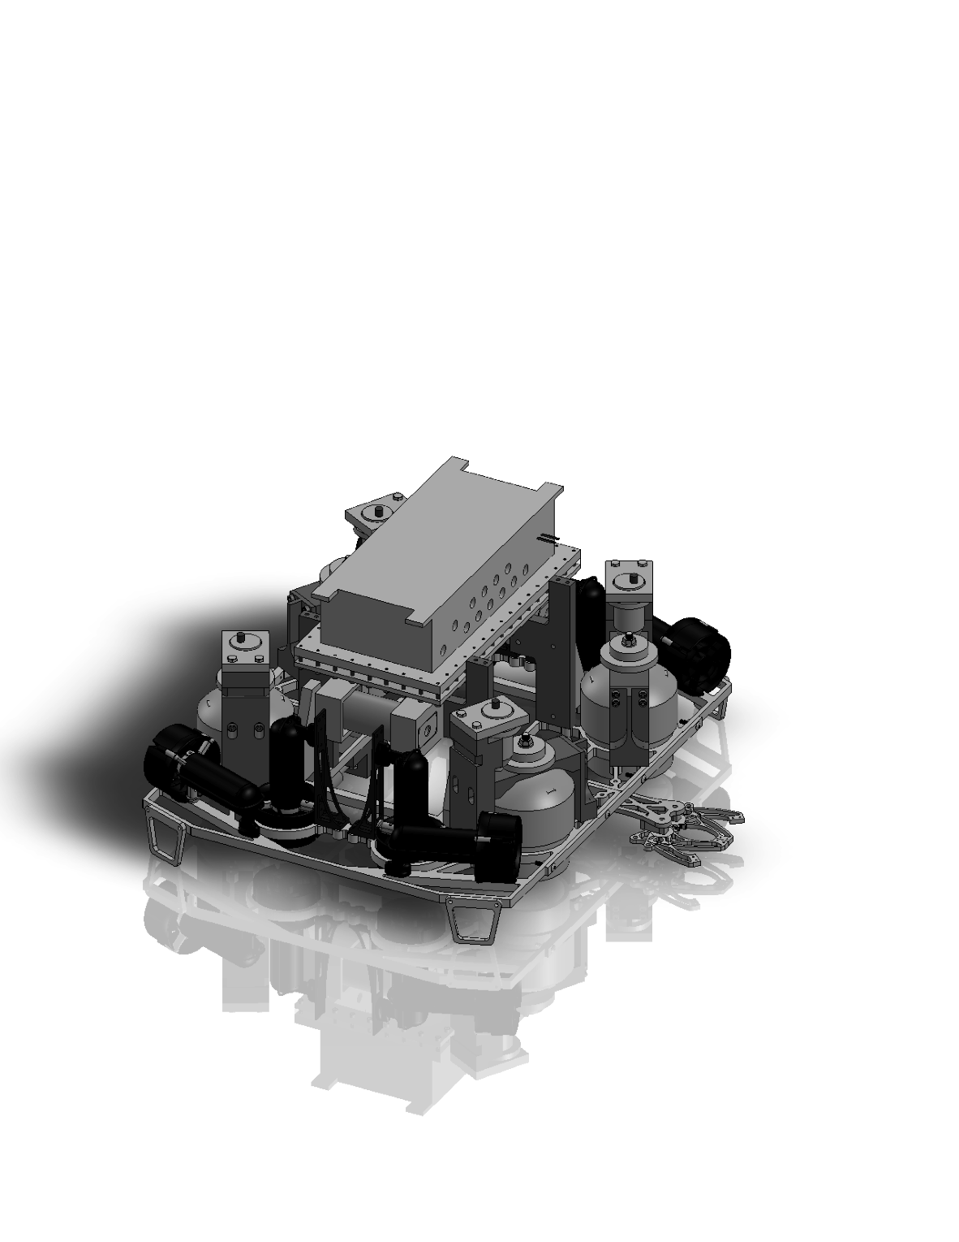

**Total Cost of ROV: $20,758.90 USD Total Weight in Air: 19.0 kg**

Overall Dimensions: 71 cm x 69 cm x 51 cm

Primary Materials: aluminum, stainless steel, polyoxymethylene (delrin), high-density polyethylene, polycarbonate

Special Features: immense power to weight ratio, lightweight MIC 6 aluminum frame, high-accuracy length measuring tool, single fixed manipulator for simplicity, entirely custom onboard electronics system and software

Key Safety Features: shrouds on all propellers, plastic propellers, complete FEA analysis with a safety factor of 2,

all electrical wiring sealed with liquid electrical tape and heat shrink, multiple fuses throughout electrical system, emergency quick release pneumatic valve

Model N

Distance Traveled: 2915 KM

----------------------------------------------------------------------------------------------------------------------------------------

Year Competing: 5th Year

----------------------------------------------------------------------------------------------------------------------------------------

2012 Finish: 2nd Place

----------------------------------------------------------------------------------------------------------------------------------------

Range of Grade Levels:

Sophmore to Senior